RESUME

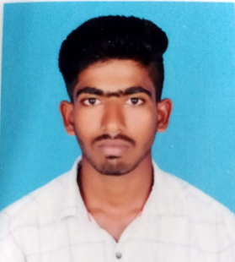

**NAME:KUMARAVEL.P**

**CELL : 86673833232**

**ADDRESS :**

S/O RAMASAMY

11/61 PALLATHUPATTY

VELLAPATT(PO),

KADAVUR(TK),

KARUR(DK)639119

**Email:ramasamykumaravel7@gmail.com**

**CAREER OBJECTIVE:**

To obtain a position that will enable me to use my organizational skills. Educational background and ability to work well with people thereby contributing to the organization.

**EDUCATIONAL QUALIFICATION**

|  |  |  |  |  |
| --- | --- | --- | --- | --- |
| **COURSE** | **NAME OF THE SCHOOL/ COLLEGE** | **BOARD/ UNIVERSITY** | **YEAR OF PASSING** | **PERCENTAGE** |
| **SSLC** | Marist Hr,Sec school  p.udayapatty | State Board | 2019 | 70% |
| **HSC** | Marist.Hr.Sec School  p.udayapatty | State Board | 2021 | 80% |
| **BSC** | Dr Kalaigner Arts & Science College-Kulithalai | Bharathidasan University | 2021-2024 | Doing |

**INTERPERSONAL SKILLS:**

* **Editing**
* **Typewriting**
* **Honest**
* **Leadership**
* **Positive Thinking**

**HOBBIES :**

* **Editing**
* **Playing outer games**
* **Art work**

**VOLUNTEER EXPERIENCE :**

* **NSS – CAMP in MARIST Hr.Sec.School,P.UDAYAPATTY .Get good experience.**
* **NSS – CAMP in Ayyermalai.**

**PERSONAL DETAILS**

Father’s Name : RAMASAMY.A

Sex : Male

Blood Group : A+ ve

Age : 19

Date of Birth : 18-12-2003

Marital Status : Un Married

Nationality : Indian

Community : Hindu

Languages Known : Tamil,English

**. DECLARATION:**

I hereby state that the information given above is true to the best of my knowledge.

Date: Yours Sincerely

Place :